Success story – I

Breed savior award winner – 2013
Name of Livestock Keeper: Smt. Roja K.
Full Address: RincyNivas, Keezhathoor, Thalassery.
Phone: 09645 356193
Family Details:
Name | Sex | Age | Education | Occupation | Relationship
Smt. Roja K. | F | 38 | Std 10 | Goat keeping,Housewife | Self
Sri. Manoharan | M | 45 | Std 5 | Toddy tapper | Husband
Rincy | F | 18 | B. Com | Student | Daughter
Sneha | F | 15 | Std 10 | Student | Daughter

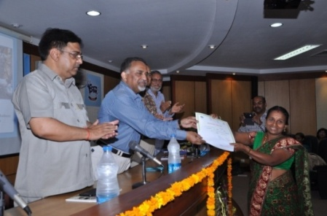
Smt. Roja K., W/o Manoharan, RincyNivas, Keezhathoor, Thalassery a housewife started goat rearing from 2010 after the intervention of AICRP on Malabari goat. Her husband is a toddy tapper and owns 27 cents of land, used for cultivation of banana and coconut. But years back, they found it difficult to run the family when the coconut prices slumped in the market. Smt. Roja started a goat rearing unit on the advice of AICRP on Malabari goat with 2 goats and started to realize the potential of sustained income. Now, she owns 36 goats and earns a good income of about Rs.1,5000/year through the sale of kids, milk and manure.

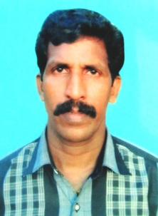
Success story - II

Breed savior award winner – 2015

Name of Livestock Keeper: Sri. Manoharan
Full Address: Kovilakaththazhakkuni, Thiruvulloor, Badagara.
Phone: 09495755047
Family Details:
Name | Sex | Age | Education | Occupation | Relationship
Sri. Manoharan | M | 39 | Std 7 | Goat keeping, Cooli | Self
Smt. Rajitha. | F | 32 | Pre-degree | Toddy tapper | Wife
Aswin | M | 14 | Std 9 | Student | Son
Anunanda | F | 11 | Std 6 | Student | Daughter

Sri.Manoharan, Kovilakaththazhakkuni, Badagara a cooli laborer, owner of 36 cents of land started goat rearing a decade ago as a small unit with few does, since he didn’t have a consistent job in the sector. After few years the productivity of the goats reduced abruptly, the kids born were weak and were susceptible to diseases and eventually led to a great loss. Subsequently AICRP registered the farmer as a beneficiary and provided superior bucks to him and created awareness about the consequences of inbreeding and importance of buck rotation. He is now rearing a unit of 40 goats with the advice of AICRP on Malabari goat and started to realize the potential of sustained income. He earns a good income of about Rs.9000/month through the sale of kids, milk and manure.

Success story - III
Breed savior award winner – 2015
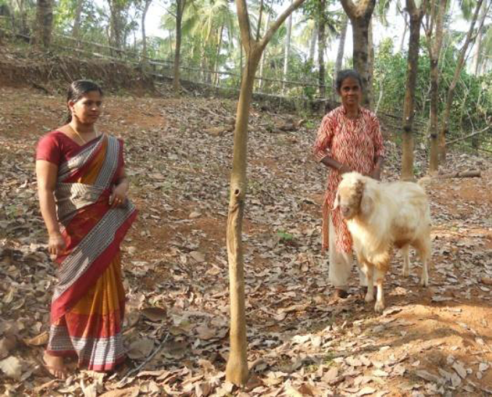
Name of Livestock Keeper: Smt. Santha Baby
Full Address: Edamana, Pandirikara, Avaduka (PO), Perambra.
Phone: 8086110817
Family Details:
Name | Sex | Age | Education | Occupation | Relationship
Smt. Santha Baby | F | 59 | Diploma in Nursing | Agriculture | Self
Sri Baby James. | M | 59 | High School | Agriculture | Husband
Sri. Shibu | M | 33 | High Scholle | Agriculture | Son

Smt. Santha Baby, Perambra is a farmer and owner of 4.5 acres land, started goat rearing three years ago as a small unit with two does, since the revenue from rubber plantation fell sharply. Subsequently AICRP registered the farmer as a beneficiary and created awareness on breeding, feeding and management practices. Now she is rearing a unit of 23 goats with the advice of AICRP on Malabari goat and started to realize the potential of sustained income. She sells 4-5 kids for breeding purpose and utilizes the manure for agriculture.

